Tab 4

Security RX Agent: Launch Planning (LP)
This document outlines the three key areas required to reach Launch Plan (LP) status for the Security RX Agent, defines the scope for various workstreams, and details current platform limitations and necessary Public Preview (PP) / General Availability (GA) capabilities.

3 Areas to Achieve Launch Plan (LP)
We know whats running in your environment
The path to LP status requires alignment and completion across three primary dimensions:

- Scope Definition & Alignment: Krystle to review current POC and suggest changes
- Platform & Agentic Core Readiness: Ensure the core agentic platform can support the defined MVP workflow, address known limitations (e.g., state consistency, attribution), and have the necessary foundational components built (e.g., Low-code agent orchestrator).
- Cross-Functional Readiness (UX/Review/GTM): Complete all necessary user experience (UX) and Security, Legal, and Compliance (SLC) reviews, finalize the Go-to-Market (GTM) strategy, and have the initial evaluation framework for agent performance in place.

Defined Scope for Launch Plan (LP)
The following table summarizes the scope for various workstreams necessary for the LP:

Workstream | Scope for Launch Plan (LP) | Dependencies / Notes
Scope Definition | Focus on library upgrades (instead of IaC) for initial MVP/LP demo and release. | Alignment with GitHub Universe/Ignite timing. Requires re-tooling the current IaC demo.
Agentic Platform Work | Confidence Score: Implement the agent's confidence scoring mechanism to inform automation levels. SRX Touch Point: Retain the current "Remediate with Security Agent" option as the main entry point within Security RX (SRX). Low-code agent orchestrator: Foundational component required to manage agent execution. | See Platform Limitations section.
Reviews (UX/SLC) | Complete thorough UX review for the entire agent-assisted workflow. Complete SLC review for security and compliance of the agent's actions and data handling. | Krystle to go through review process.

Platform Limitations
Addressing these platform limitations is critical for a stable and scalable launch:

- State Consistency: Challenges in maintaining synchronization between the IaC templates and running configurations.
- Attribution (Mutations): Difficulties in accurately tracking and attributing changes or "mutations" made by the agent back to the source (e.g., who/what initiated the change).
- GitHub Integration (MCP Current Process): Existing Managed Control Plane (MCP) processes for GitHub integration may not fully support the new agentic requirements.
- Monitoring: Need to establish comprehensive monitoring for agent performance, reliability, and security of its automated actions.
- Evaluation Framework: The current "critique agent" functionality is not a full evaluation framework. This is a critical fast-follow to ensure the agent's accuracy and safety over time.

Security RX Work (SRX)
Specific work within the Security RX product to support the agent:

- Confidence Score: Implement the logic and display for the agent's Confidence Score
- Touch Point for SRX: The current option to launch the workflow via "Remediate with Security Agent" is deemed good and should be the initial touch point.
- Reviews: Ensure Krystle to go through the review process for final sign-off.

Public Preview (PP) / General Availability (GA) Needs
The following capabilities are required for the agent to move into broader PP or GA availability:

- Low-code agent orchestrator: A necessary platform component for flexible agent management and workflow creation.
- GitHub app: Required for a seamless and secure integration with the GitHub platform.
- Automated Repo Mapping: The ability to automatically map deployed services to their corresponding code repositories for Applications and IaC remediation
- Prioritization of Issues: Enhanced default prioritization for issues within Security RX to surface the most critical, newest, or highest impact vulnerabilities. The agent should then be launched directly from these prioritized issues in SRX.

Integration overivew

Proposed GitHub Copiliot + Security RX Agent Integration for Github Universe

Product integration value:
- Github users currently lack a convenient way within Github to compare IaC templates to running configurations and understand the net effect of IaC vulnerabilities For Github universe and ignite we are looking to focus on library upgrades instead of IaC. Will update based on new demo
- This leads to a disjointed approach, context switching, and fear of the unknown
- All the data required to help platform, security, and devsecops teams make informed decisions exists in Github and New Relic
- With AI assistance on both platforms we can engineers more efficiently remediate and validate potentially disruptive changes with less worry
- Copiliot and NR Security Agent show cases both platforms comprehensives in resolving IaC vulnerabilities across the SDLC at build-time with runtime validation and context
- This integration with New Relic can give GitHub (including GhAS) a competitive edge in the DevSecOps market by offering a more integrated experience, leap-frogging security centric competitors who have made acquisitions to move from runtime to buildtime security

The MVP workflow automates cloud security remediation and validation through 5 stages:
- Security Agent Gathers Context and uses RAG: Collects details on impacted services, environment, and security details. Retrieves historical data, playbooks, and current running configurations to enhance risk assessment and prepare for remediation planning and understanding the risks of both the security issue and the potential fix.
- GitHub Copilot Provides and Collects Details: Extracts IaC, repository, and deployment data, along with specific security implications, to understand the origin of vulnerabilities and inform remediation.
- Security Agent Interprets and Synthesizes Details: Assesses all collected information to create a risk profile and a confidence score, determining the level of automation versus human intervention.
- Security Agent Constructs Remediation and Validation Plan: Develops a clear plan including remediation steps, impact summary, and validation, initiating automated deployment or human-intervention depending on confidence.
- GitHub Creates Tailored Remediation Spec: Generates a GitHub issue with all necessary context for engineers, bridging build-time and runtime insights for efficient resolution. Validates not only was the deployment successful but went to all identified resources.

From prioritization to execution and validation, cloud security fixes are handled end-to-end with automation and transparency, fostering trust and efficiency.

Elevator pitch for Security RX Cloud:
Is your cloud security a tangled mess of siloed data and endless context switching? Security RX for Cloud unifies your security and posture management, giving you a single pane of glass to discover, manage, and remediate cloud misconfigurations. We contextualize security findings with runtime configs, ownership, and operational details. Then provide remediation options that prioritize the highest risks, and help understand their blast radius. This means faster resolution, improved team collaboration, and a clearer understanding of your security posture. Ready to simplify your cloud security and achieve peace of mind?

MVP Scenario: Automated Cloud Remediation Prioritization and Planning
Mario, a platform engineer, noticed some changes to an S3 bucket on a Friday afternoon. He saw several security issues tied to it but was hesitant to act quickly. In the past, making changes without fully understanding the net effect has led to unintended side effects, such as an S3 bucket that was accidentally opened to the internet. That incident caused a traffic spike and increased their AWS bill, although thankfully, it didn't lead to a security breach.

This time, Mario has a better solution. He uses New Relic's Security RX and its integrations to pull data from all their security tools, saving time and effort context switching between tools. Instead of manually switching between windows researching, copying IaC snippets, and applying the fix hoping it doesn’t have any unintended side effects, the security agent automates this process. He selects the option to "Remediate with Security Agent" to get his help ensure he’s got the best plan of action.

1) Security agent starts off gathering all the necessary details and context on the resources:
- Basics: Impacted services(s), host(s), environment details (cloud, region, VPC)
- Security details: Detection date, exposure, severity
- Environment: Teams/ownership, tier, environment, business metrics (users, revenue)
- Dependencies to understand potential impact areas and blast radius of any changes made
- Historical performance data to understand trends in traffic patterns
- Past change events to understand what's typical timing for changes to occur (change tracking data or potentially Github directly)
Why? This context will help the agent assess the risk of a change and potential side effects. It needs to put these into human context assessing things like if the resource is business critical, under high load, is likely to have a significant impact on downstream services or low risk as it’s a backend service. This will also provide details like time of day, day of week, ‘rustiness’ of the resource or likelihood change will occur during a regular maintenance window. All of which could inform the agent’s eventual decisions or recommendations to human responders. Risk comes in two forms - the security risk of not addressing the issue and the risk of change based on environmental factors that have to be considered together.

1.5) Security agent uses RAG to retrieve (I don’t know how much of this is really available today)
- Additional relevant historical data on similar security issues and deployments
- Related security tickets
- Static Security Remediation Playbook: Our rich, pre-generated content that knows the ideal, secure state for a resource and provides the necessary fix templates (CLI, Terraform, etc.
- The resources current running configuration - The actual, current state of the misconfigured resource, fetched in real-time from the customer's AWS account
Why? This helps enhance the risk assessment by compiling evidence about past similar changes to this resource leading to incidents (along with severity and impact data, etc.). Indexed runbooks will also prepare it to advise on a likely good remediation and generate a ‘diff’ view for side-by-side comparisons.

2) Github Copiliot is provided details and collects additional details
- Copiliot extracts related information for impacted resources including IaC details, repo details, deployment details including config from the detection date, and last known deployed config
- Copiliot collects relevant details from GhAS (CodeQL) including the specific line of code, the type of issue, and often, explanations of the security implications. I will also collect other known related security issues from GhAS (code, secrets, etc).
- Copiliot can also leverage autofix to generate a remediation plan if know
Why? Understanding build-time data and other security events will provide a better understanding of the origin of the IaC vulnerability, compare detection dates across many runtime resources with config changes to understand if there are potential deployment issues or mixed states.

3) Security agent interprets all current conditions and synthesizes details to:
- Creates a risk assessment or profile that will determine the relative risk of a change and inform how quickly to fall back to Mario is a problem occurs
- Assess the importance of gaps in available data that may affect its ability to correctly identify a risk or remediation.
Why? By noting and weighing visibility issues it will be easier to determine if it’s probably for success and offer a confidence score to build Mario’s trust. It will also help the agent decide when to “fall back” to copilot mode and help a human vs. striking out autonomously.

4) Security agent constructs a remediation and validation plan:
Now that the agent has synthesized the data and has ‘opinions’ it needs to construct a plan on how to do its ‘cloud security’ job. The agent plots out what it and other agents should do next in order to complete the job. This “plan of action” is greatly influenced by the agent’s own confidence in its ability to do the job on its own. If its confidence score is below some configurable threshold, it will prioritize “human in the loop” steps as part of its plan. Note that this plan of action could comprise multiple New Relic WorkItems and integrations. The next section is an example using Github specifically:
- Creates a remediation plan
- Provide a summary of the issue
  - Details on when it was first detected, if it’s in both the repo and running service, and any potential differences from the two environments
  - Recommended remediation path with side-by-side diff of changes
  - Impact of the fix e.g. this will resolve 20 misconfigurations across 8 services, 2 in Tier 0 with public exposure, effectively securing an average of 500k users globally saving $100k in potentially mitigated downtime. Based on past deployments there is a relatively low probability deploying this now will cause any negative impact.
- Deployment initiated via GitHub Actions for bulk fixes
- Validate the fix was deployed to all instances
- More to be added in MVP+ on validation of unintended issues
- Depending on the confidence (configured threshold or just user option) it will alert Mario and wait to execute the plan
Why? A detailed execution plan explains the ‘how’ the agent came to the conclusions in simple human terms with full transparency. This builds trust and confidence in the agent.

5) GitHub creates a tailored remediation spec to address the issues
- Github issues created and automatically populated with all the necessary context: the finding details, the affected resource ARN, the business impact, and the exact CLI/IaC snippets required for remediation.
- Github copilot confirms the deployment was successful and went to all identified resources from NR Security Agent
- Github copilot notifies security agent when deployment is complete and if there were any issues
Why? Security Agent and Copiliot act as a bridge between the remediation plan and the customer’s established engineers workflows reducing toil and risk by combining insights from build-time and runtime for comprehensive review of security remediations

Mario believes in the old security adage, trust but verify, and with the Security RX Agent and Github Copiliot, he has all the details he needs to feel confident to either let them make automated actions or let him decide.

MVP+ Scenario: Continuous Monitoring and Rollback Recommendation
While Mario logs off for the weekend, the Security RX Agent continues to work, vigilantly monitoring the resources. It already validated that the fixes were correctly applied to the right production instances and nothing was missed. It is now going to monitor key metrics like traffic throughput and cost. If any abnormalities appear, the agent will gather details and alert Mario with recommendations on whether to keep the changes or roll them back.

Mario was able to relax at home, confident that the Security RX Agent would handle any issues and keep the system running smoothly. He has someone continually monitoring and knows he'll get an alert him if there are any issues.

MVP+ Scenario:

https://newrelic.atlassian.net/wiki/spaces/SLCIT/pages/3857711114/SIRT+-+Critical+Vulnerability+Response

Demo story board

Demo Storyboard : Github Universe

Step 1: impersonate Link
Step 2: PR build link

Setup : We started with the premise that security tools aren’t built for the developer experience, they’re built for security teams. Dependabot has been a great security tool because it integrates seamlessly into development pipelines giving the security team an easy way to have guardrails for developers and compliance teams the reporting they need. Developers still feel like they waste a lot of time on security issues. Why, though? Let’s think about the questions most have to ask and go through to get to a remediation:
- Is this a real issue that's actually deployed to production or just sitting in code somewhere?
- How serious is the problem and what’s the risk of making a change right now?
- What do I actually need to do to remediate this?

At each of these stages there’s a lot of wasted time because data is siloed leading to context switching. Even if it’s a simple vulnerability and takes 5 minutes, 1000 issues can waste 83 hours in a week with half of those resulting in nothing. How can we help?

(Note: We can show Security RX as the starting point or just jump straight into the agent - when I did this live the total demo time was only 5-8 minutes including the setup)

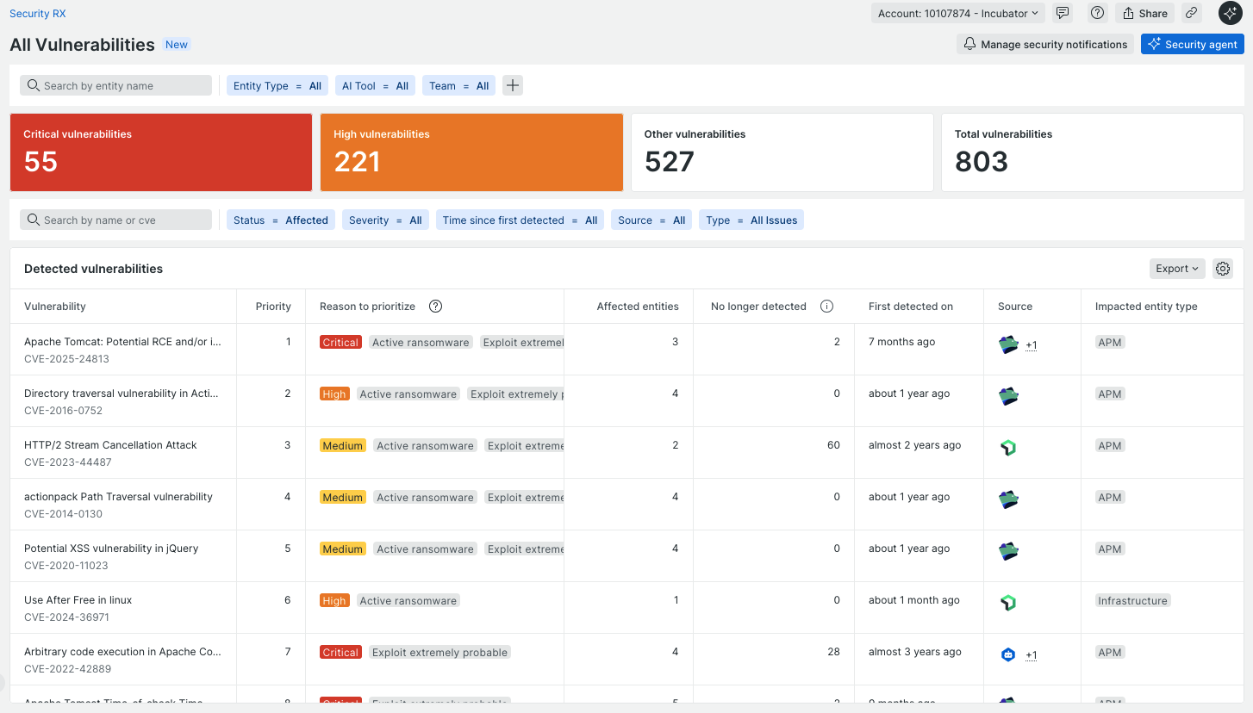 | 1st Security RX provides a unified view of security issues from multiple sources into one place -runtime application & infrastructure form our agents as well as SCA tools like Dependabot that are scanning the code  We prioritize these and give you various ways to slice and dice the information to get what you’re interested in. Maybe you’re an engineer on the Vuln Mgmt team and only want to see the issues that your team owns  Filter to team Vuln Mgtm
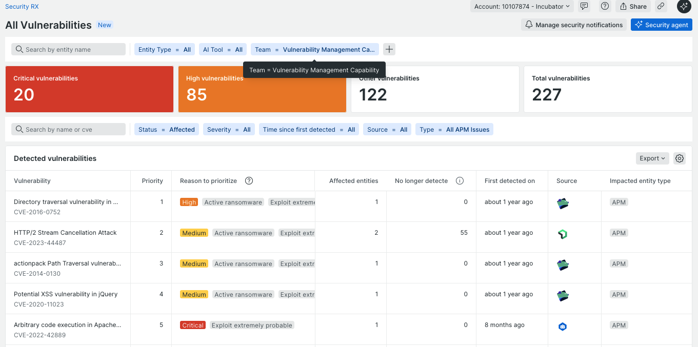 | Once you have it scoped to something more manageable what do you do next?  You could go through each of these one at time, start to look at aggregates like libraries that are problematic, or we could jump straight into getting it fixed  Select Security Agent  (Note: Would be good to find an example that included running vuln + Dependabot in repo  Example that would work in staging https://staging.onenr.io/0Bj3BXyGkRX )
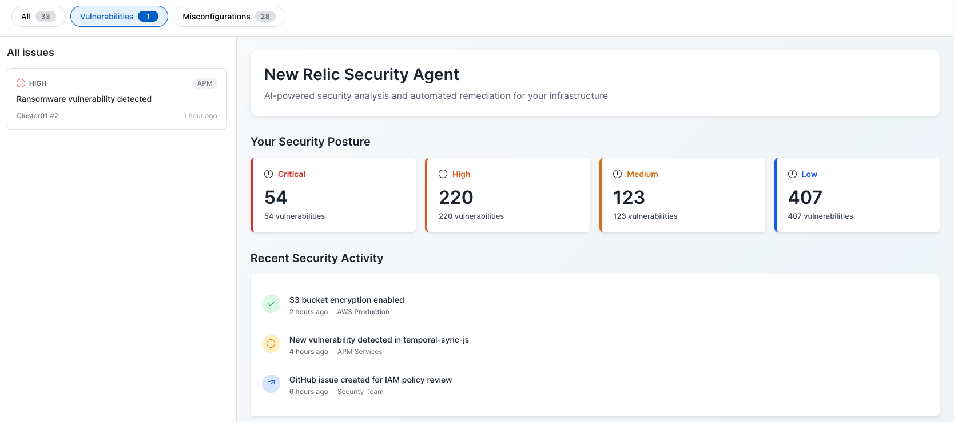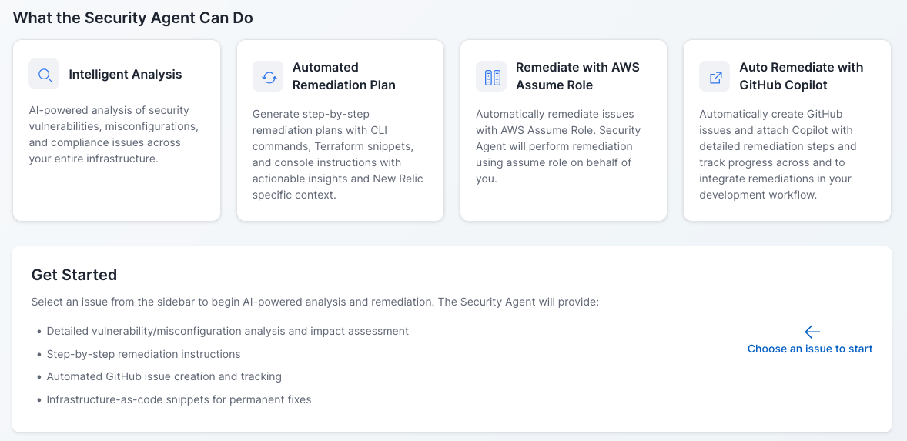 | Quick overview of all the security agent can do  Select ransomware vuln  (https://staging.onenr.io/0Bj3BXyGkRX)
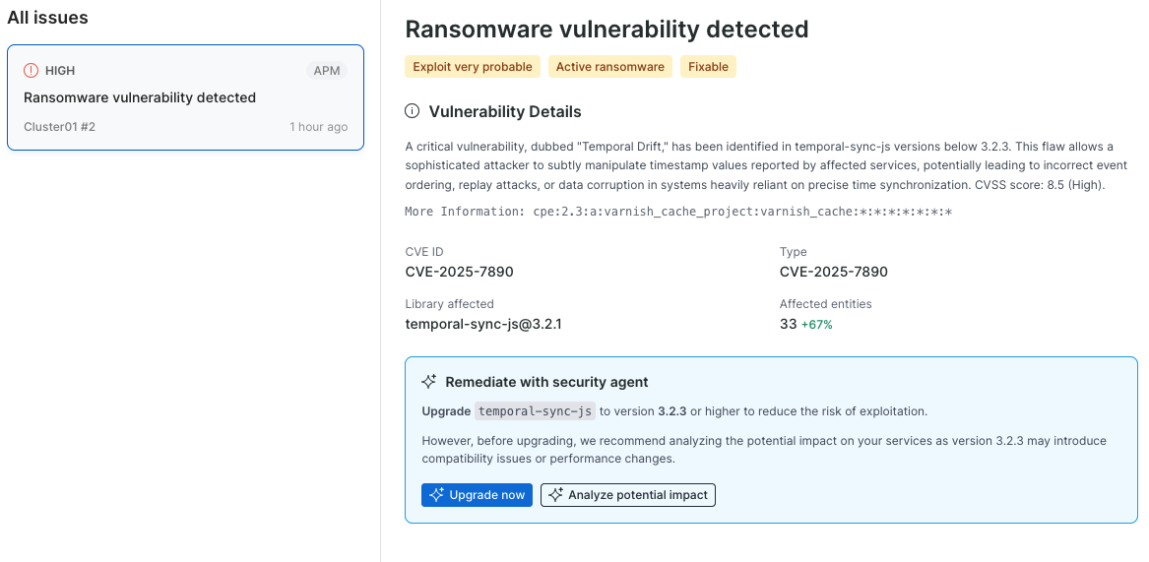  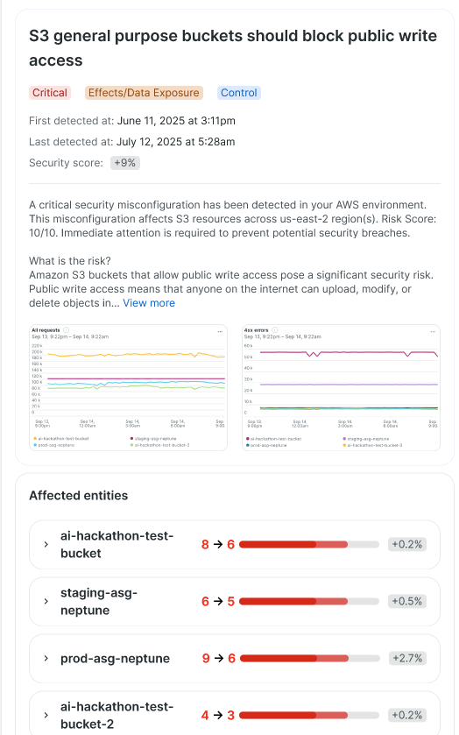 | At a glance you have a quick overview of the CVE its impact across your environment but you want to understand some more of the nuances  Analyze security and operational impact  *Note: Can we add in a breakdown of entities across environments (staging vs prod), first detected, last detected,other CVEs resolved by the library upgrade, number of requests, internet exposure, and then a visualization similar to the one below overlaid with deployment markers 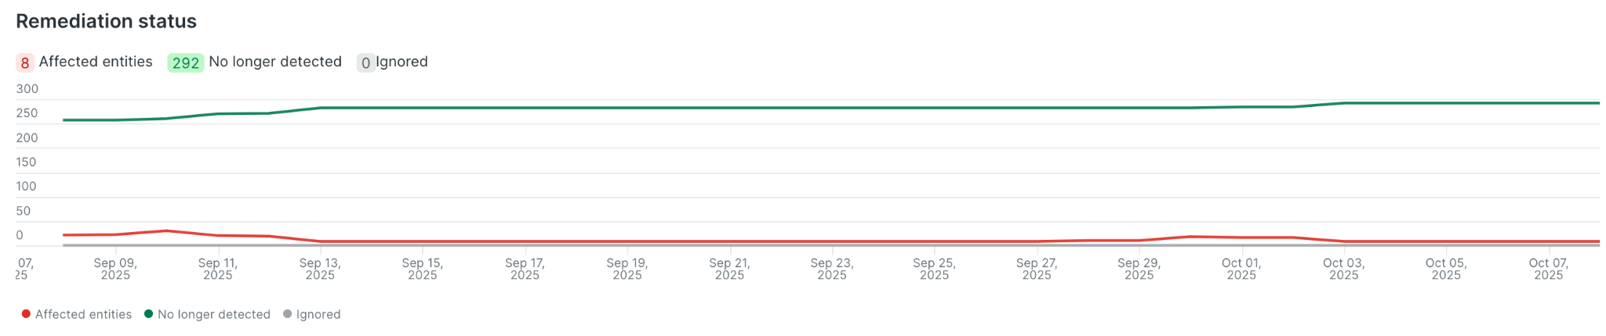  *Other ideas  - Show two prod instances that both have internet exposure where one has no active traffic or has not had any in weeks vs one that is very active - when we are focused on singular upgrades understanding priority is important  We can help provide more context around this CVE and relate a security issue back to the environment like staging vs production, help prove it’s there, and provide add’tl risk context like CISA Kev. We can also give you a sense of the service itself - is it handling a lot of requests right now that could affect when we’d want to do this upgrade? Are there downstream services (maps) that this could affect as well or maybe they have sensitive data so this needs to be handled rather quickly.
Quickly you’re able to access the overall situation and then decide yes, this is an issue we should go ahead and fix right now.

Generate remediation plan
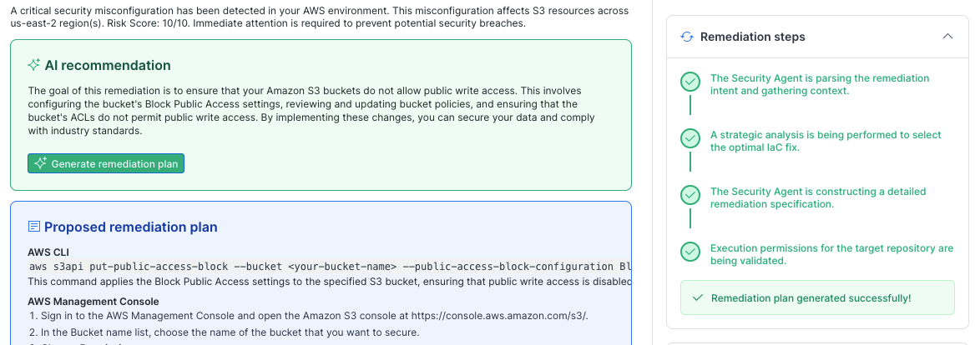 | Cover the steps it’s taking and the proposed plan  Approve the create github issue
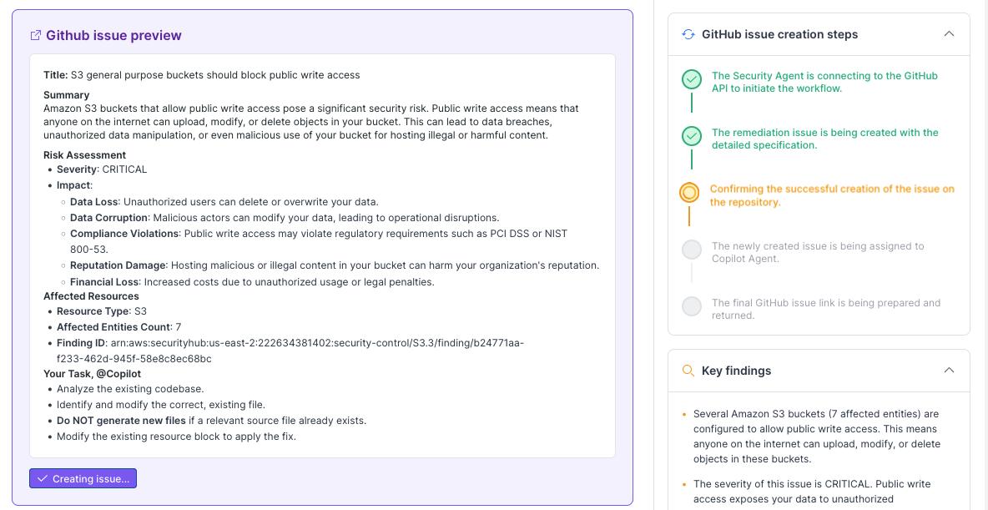 | Review github issue  Create issue  Talk through the steps (mix of agentic and automation)
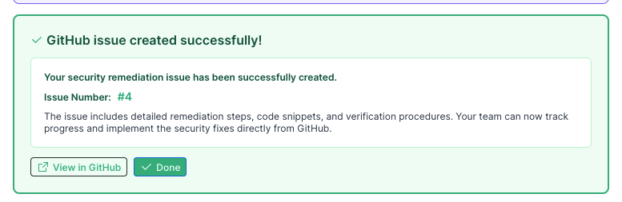  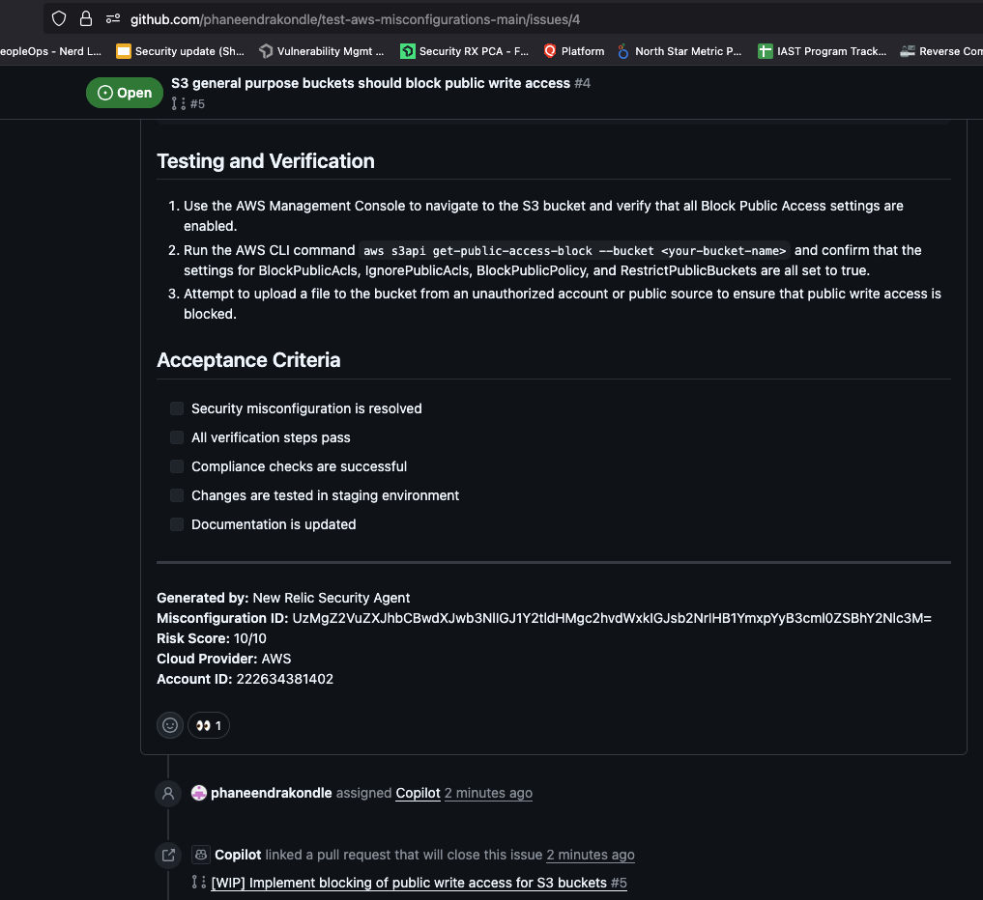 | View in Github  Cover the basics of the issue (summary of all the details we had before) and then we give Github a quick plan with options for remediation and validation automatically  PR Tab (find one that’s already done)
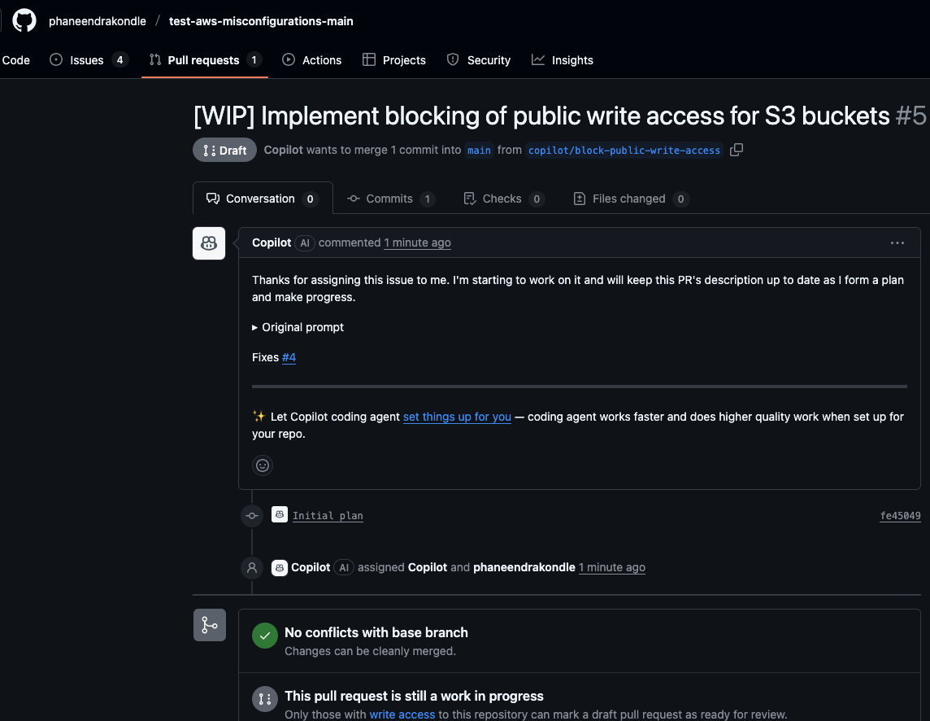 | Cover the PR details - Within 10-minutes the copilot agent was able to take all those details and turn it into a PR thats ready for review and submission.  It saves you not only a lot of time but be a lot more effective making quick decisions with less risk

Current staging environment focused on IaC vulns https://staging-one.newrelic.com/vulnerability-management?nerdpacks=vulnerability-management%40PR-576&account=10107874&state=1283bea0-8d73-7f21-1992-7b9b31f2e345

Figmas focused on Cloud and IaC vulns
https://www.figma.com/proto/KD2P7FTxDGEcDIb42PpFae/Untitled?node-id=1-17697&t=icugiATh0A6KCLgj-1&scaling=min-zoom&content-scaling=fixed&page-id=0%3A1&starting-point-node-id=1%3A265084

mcp_booth_demo_2025-10.mp4

Partnership details
Use case:
An AI-powered integration that bridges GitHub's build-time data with New Relic's runtime insights for complete IaC vulnerability resolution across the SDLC. This gives GitHub a competitive DevSecOps advantage, moving from found to fixed efficiently with full runtime context.

Next steps:
- Engage with GhAS and Github Copiliot teams to show the POC we've built to get their feedback and input
- Need to agree on technical integration details, shared responsibilities, and mutual benefits for joint customers, Github and New Relic
- Take early POC to lighthouse customers to solicit additional feedback
- Outline what a short term roadmap looks like - phased development for the MVP integration, marketing, and GTM motion
- Long term: Explore additional opportunities to enhance the integration bringing in additional security signals from GhAS and 2-way communication between agents for more advanced use cases

including testing, joint demoing, and solution briefs

